The Sea Book 4
by william niu
a book about 4 kinds of sea creatures
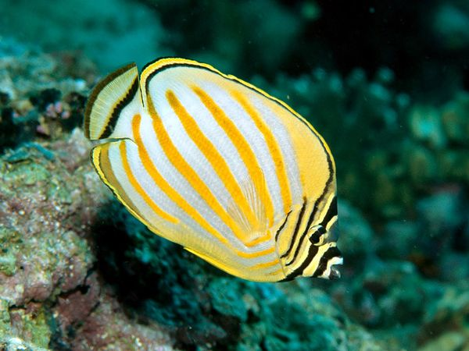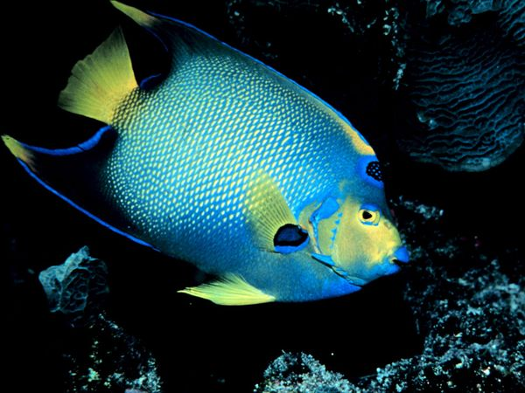
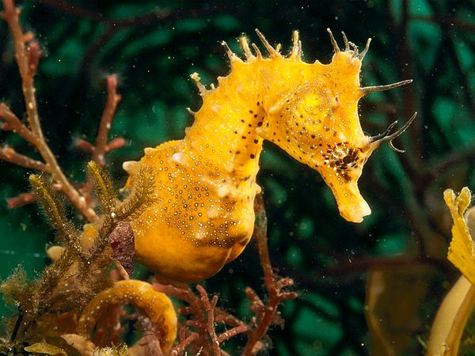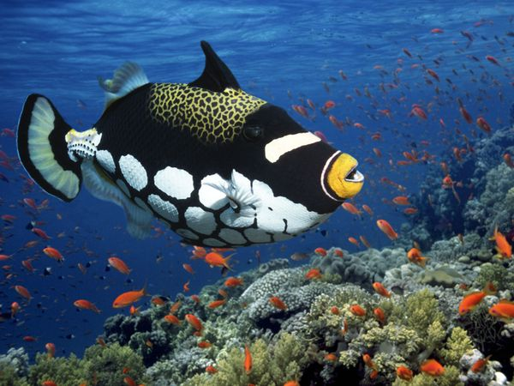

The Butterfly fish
What fish is as beautiful as a butterfly? What fish pattern to its stripes? What fish like to eat polyps and worms?
What am I?
Can you find me in this picture? 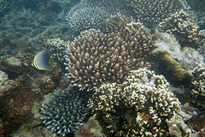
I am a butterfly fish.
A butterfly fish is a very common site near the coral reef. They can be found throughout the world but they only live in coral reefs. There are about 114 different kinds of butterfly fish in the world! They are very thin, almost as thin as a disk. Butterfly fish is only the size of a tea cup (8 inches). Every one of them should have a pattern of its stripe. Different kinds of butterfly fish have different colors, such as blue, red, orange, or yellow. Butterfly fish can blend in the background with their skin color.

Map
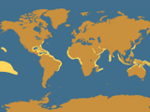
Butterfly fish Range

A butterfly fish searching for polyps and worms for its next meal.

The Queen anglefish
What fish have a blue-ringed black spot on their head? What fish got its named of that spot that looks like a crown? What fish is very shy?
What am I?
Can you find me in this picture? 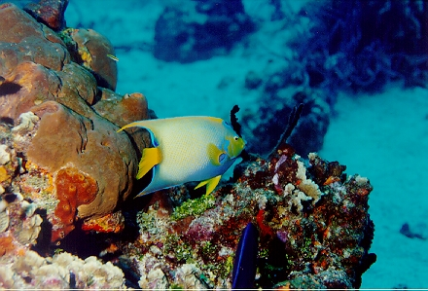

I am a queen anglefish.
Queen angle fish’s name is named after its blue-ringed black spot that looks like a crown which people think it looks like a queen and so people named it queen anglefish. They are a shy fish. They often live in the warm waters of the Caribbean and western Atlantic. They are a shy fish. But they have beautiful colors on their body. Their body could be blue or bluegreen. They like to eat jellyfish, corals,plankton and algae. A queen anglefish can live up to 15 years and can be as long as 18 inches!

Map
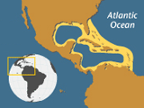
Queen Angelfish Range
The queen angelfish gets its name from the crown-like ring on its head.

The seahorse
What sea creatures look like yellow horses floating in the sea? What sea creatures’ babies are being born by the male? What sea creatures are rare and people made medicine out of them?
What am I?
Can you find me in this picture? 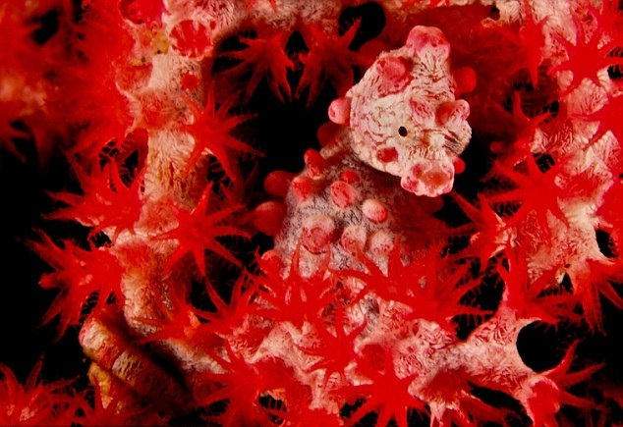

I am a seahorse.
Seahorse is a very strange and very beautiful animal. They are very strange because we know most creatures’ babies are made by their mother. But the baby seahorses came for their father! They looks like they are strange but they are beautiful. They can turn themselves into the color of the surroundings. A seahorse can live between 1-5 years. They are found throughout the tropical water of the world. They can be small or large. They can be 0.6 inches or they can be 14 inches! There are about 43 different kinds of seahorses in the world.

Map
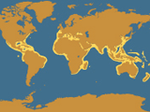
Seahorse Range
A seahorse finding tiny sea grasses and corals.

the triggerfish
What fish has white spots on the bottom of their body and a leopard looking spot on their back? What fish like to dig out preys such as crabs and worms?
What am I?
Can you find me in this picture?
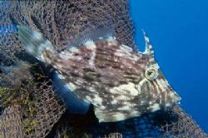
I am a triggerfish.
There are about 40 different kinds of triggerfish in the world. They look like they are very small. But they are bigger than you think. The biggest can grow up to 3.3 feet! Triggerfish can be very pretty. Some kinds have white spot and have a spot that look like a leopard’s skin. They like to eat crabs, worms and also sea urchins.


Triggerfish are very pretty.

