The Sea Book 5
by william niu
a book about 4 kinds of sea creatures
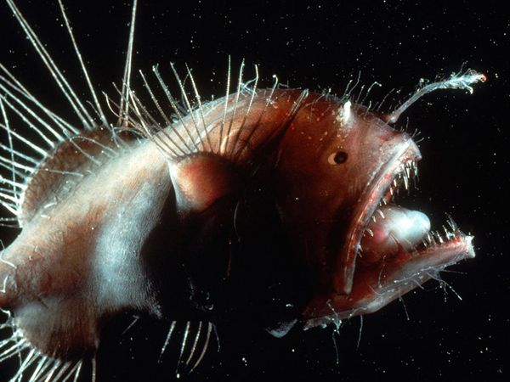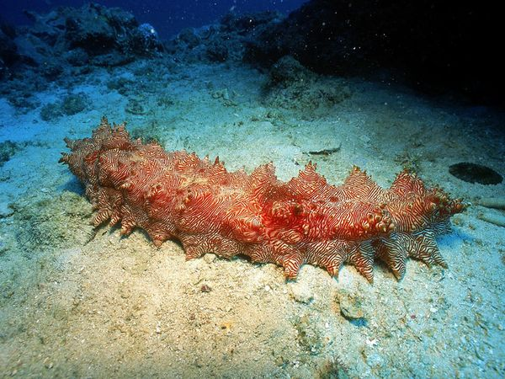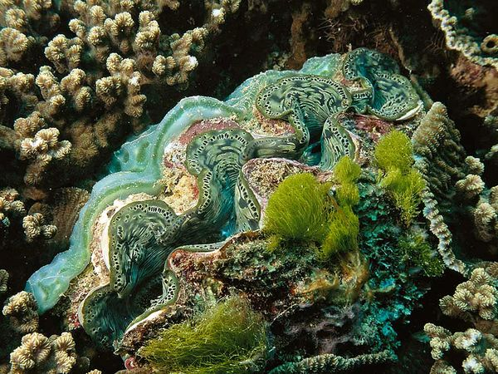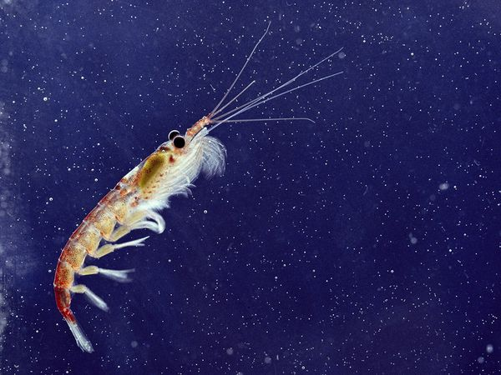

The anglerfish
What fish live in the deep sea with a “light” dangling from its head? What fish use the light to see in the darkness deep sea?
What am I?
Are scared of this fish?
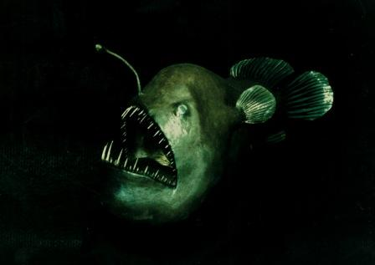
I am an anglerfish.
Anglerfish live in deep waters of murky depths of the Atlantic and Antarctic oceans. That is about 1 mile from the surface of the sea. There’s about 200 species of anglerfish. Different species have different body size. They can be small as 8 inch or as big as 3.3 feet. Bigger ones can weight up to 110 pounds! The very special supply on an anglerfish is the lantern like light dangling from its head. Angler fish use it to see in the darkness. The light actually provided light for millions of bioluminescent bacteria.

Map
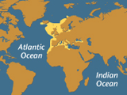
Anglerfish Range

Anglerfish look very scary.

Sea Cucumber
What fish looks like a giant fat worm crawling on the ocean floor? What sea creature belongs to the category of echinoderms?
What am I?
Can you find me in this picture?
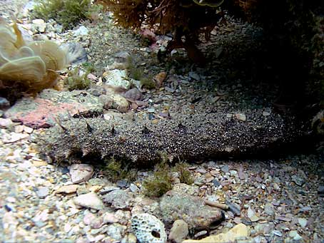
I am a sea cucumber.
Sea cucumbers come in all shape. They can change their color to blend in the surrounding. They can be find throughout the whole world. A sea cucumber can be poison too. Sea cucumbers feed on algae. You think they eat a little but sea cucumber can be 0.75 in to 6.5 feet! There are about 1250 known species but a lot had not been discovered. Each species have its very own size. Sea cucumbers come in all sizes. Some come out with things look like spikes sticking out of their body. Some can even look like a hot dog!

Map
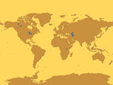
Sea Cucumber Range
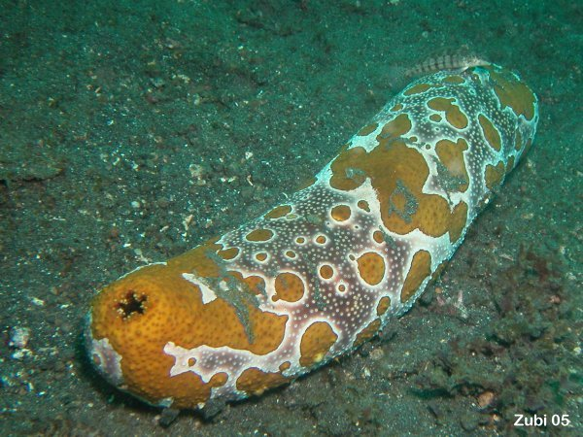
Sea cucumber can look very strange.

The giant Clam
What sea creature looks like a large shell hiding in near a rock? What “shell” looking like thing can weight up to 440 pounds?
What am I?
Can you see me in this picture?
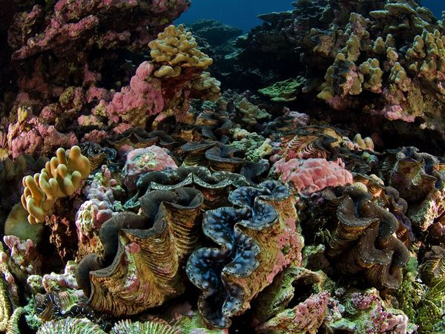

I am a giant clam.
Giant clams love in the warm waters of the South Pacific and Indian Oceans. The often hide between rocks. They are very huge and heavy. They can be as long as 4 feet and as heavy as 440 pounds. The interesting thing about giant clams are when they spotted a nice, safe spot between rocks for themself, it stays there for the rest of its life.

Map

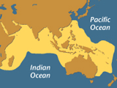
Giant Clam Range

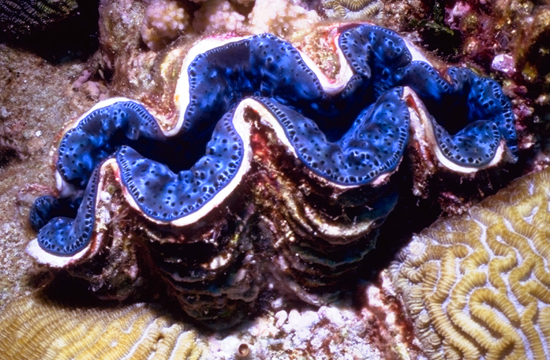
Giant clams are huge.
The Krill
What shrimps are about 2 inch that lives in the sea? What is baleen whales’ favorite food? What shrimp eat phytoplankton and microscopic?
What am I?
Can you see how tiny I can be in this picture?
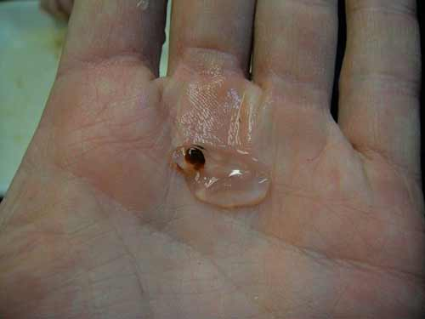

I am a krill.
A krill is a very small shrimp about 2 inches. They live worldwide and baleen whale’s favorite food is krill. Whales eat tons of krill each day! But a krill only weight 0.035 oz. They have hundreds of predators so they need to escape fast. They have predators such as fish, to birds, to baleen whales. Most krill often feed on phytoplankton and microscopic. There are about 85 known species. There are about 125 million tons to 6 billion tons in the waters around Antarctica!

Map
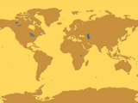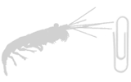
Krill Range

Krill are baleen whales’ favorite food.

