the sea book 6
by william niu
a book about 4 kinds of sea creatures
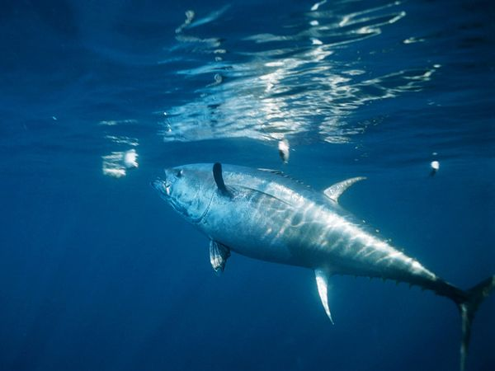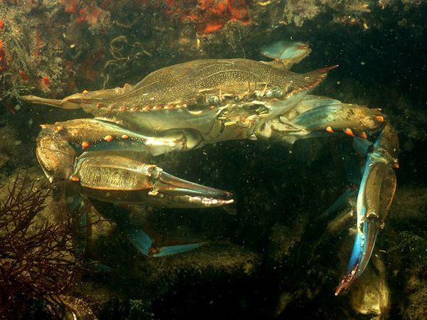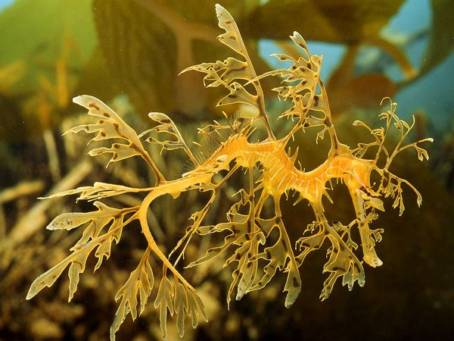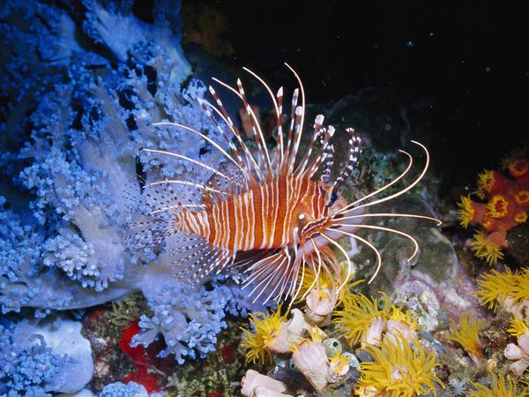

The Atlantic Bluefin Tuna
What tuna is one of the biggest, fastest and the most gorgeously colored of all the fish around the world? What tuna have metallic blue on top and shimmering silver white on the bottom that helps them camouflage them from above and below?
What am I?
Do you know I swim with big schools?
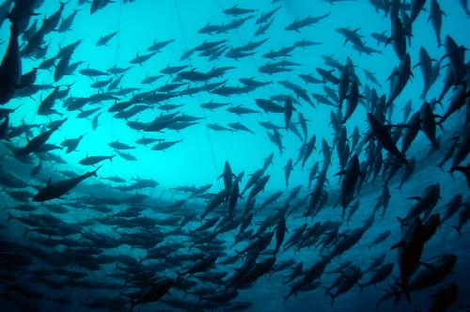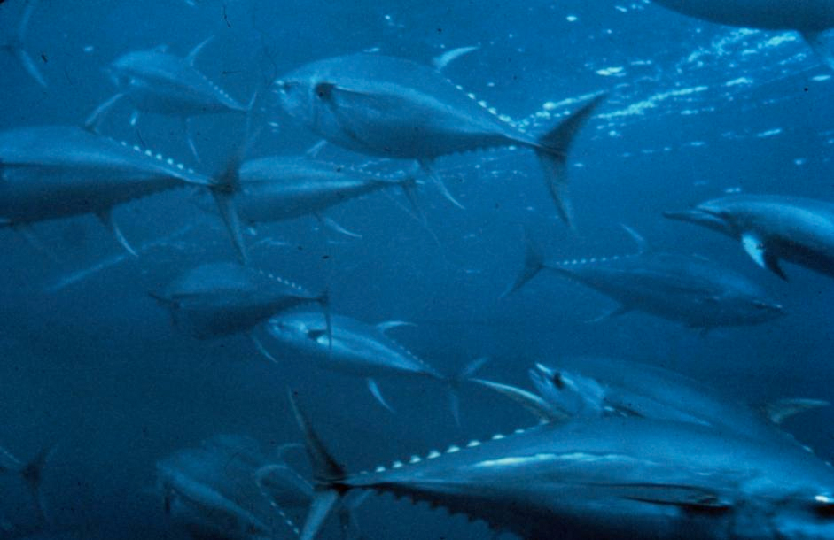
I am an Atlantic Bluefin Tuna.
Atlantic Bluefin Tuna are one of the biggest, fastest and the most beautiful fish around the world. If you think tuna is small but this kind is not small at all. It can grow up to 6.5 feet and can weight up to 550 pounds! This kind of fish is very expansive because this kind of tuna is endangered. In January, 2001, a 444 pounds Atlantic Bluefin Tuna was sold in a Japanese fish market for $173,600 (¥20.2 million), it is a world record! They often feed on smaller fish, crustaceans, squid, eels and zooplankton.

Map
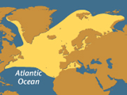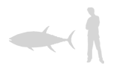
Atlantic Bluefin Tuna Range

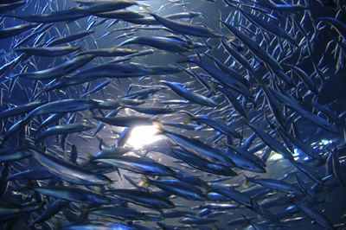
Atlantic Bluefin tuna swim in large schools.
The Blue Crab
What crab was named after its blue claws with shells brown? What crab craw with groups called cast? What crab only can be find in the brackish coastal lagoons and estuaries from Nova Scotia, through the Gulf of Mexico?
What am I?
Can you find me in this picture?
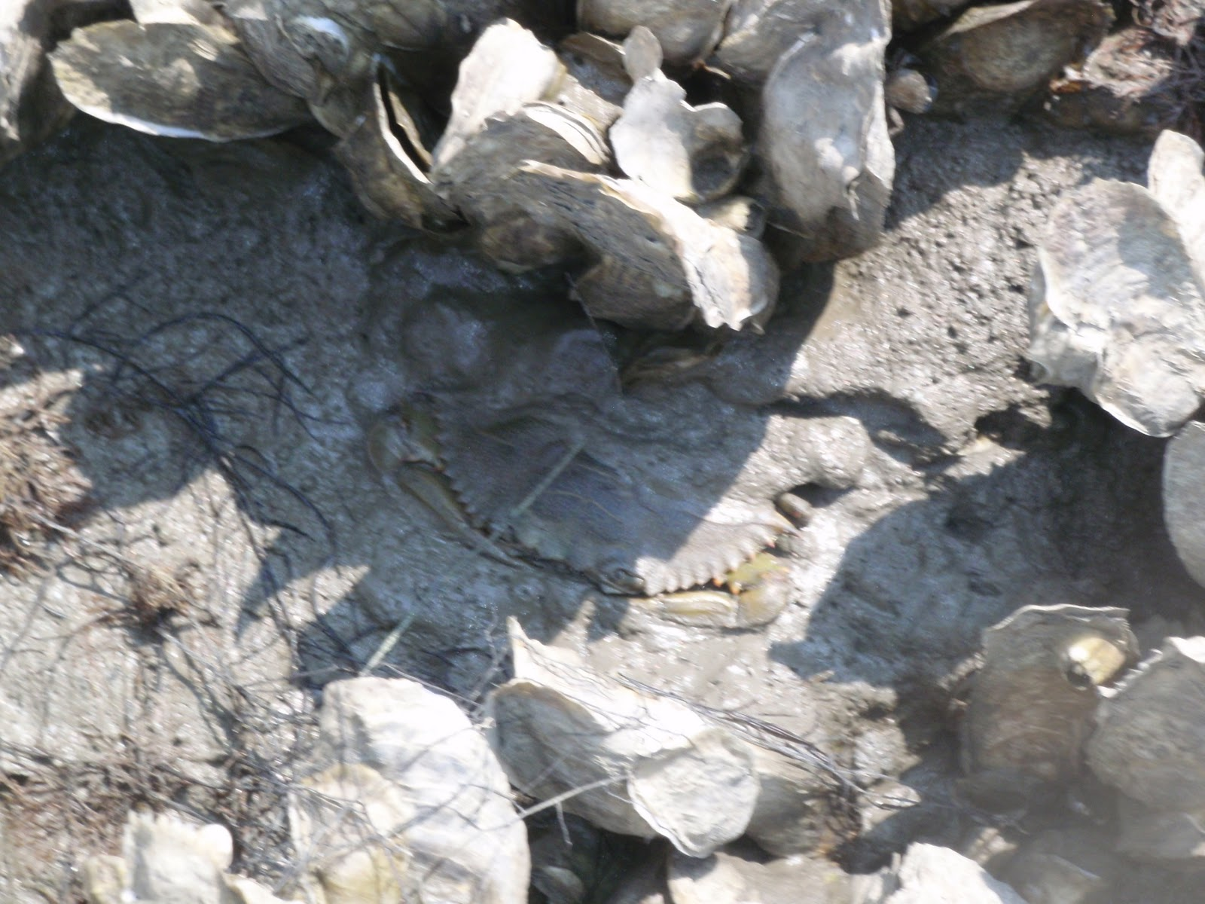
I am a blue crab.
Blue crabs are named after their blue claws. So if you next time see a crab with blue claws, that means it is a blue crab! They are found in the water of brackish coastal lagoons and estuaries from Nova Scotia, through the Gulf of Mexico. They swim in groups called cast. The females only mate once in their live. Blue crabs can reach up to 4 inches long and 9 inches. They can weight up to 1-2 pounds. They are relative to shrimp and lobster. They feed on mussels, snails, fish, plants, and even other smaller blue crabs.

Map
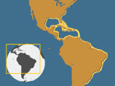
Blue Crab Range
Blue crabs have blue claws and brown shells.

Leafy and Weedy Sea Dragon
What sea creatures look like a mini dragons floating in the water. What sea creatures like to swim with fogs of tiny shrimps because they like to eat them.
What am I?
Can you find me in this picture?
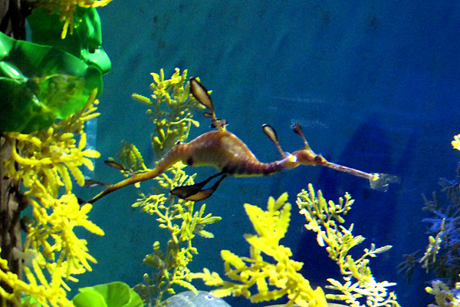
I am a sea dragon(leafy and weedy).
There are 2 kinds of sea dragons. They are the leafy and weedy sea dragons. They like to make them camouflage with seaweeds. They can only be found in the water of the south and east Australia. They are related to sea horses. They can grow up to 18 inches! Did you know that a male sea dragon’s tail turn yellow when they are ready to mate. They feed on tiny shrimps that made the water into like there is fog. They have thin snorts that are designed just right for eating tiny shrimps.

Map
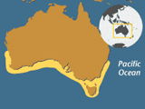
Leafy and Weedy Sea Dragon Range

Leafy sea dragon
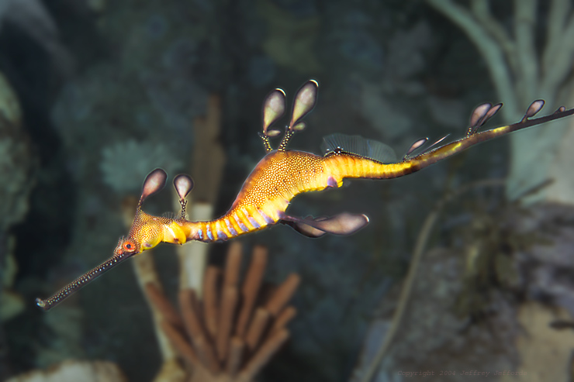
Weedy sea dragon

the lionfish
What fish are venomous with red and white zebra stripes. Their stings are there to warn you “Don’t touch!”
What am I?
Can you find me in this picture?
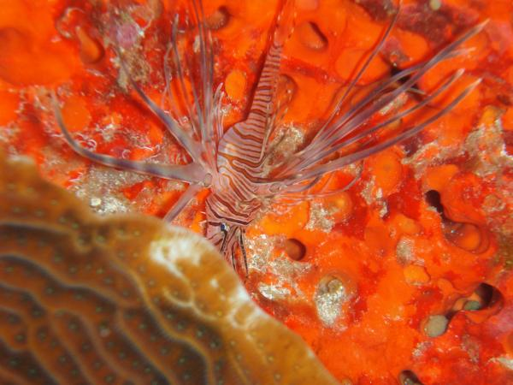
I am a lionfish.
Lionfish are very beautiful fish with red and white zebra stripes with venomous stings sticking out their back. The stings are there to warn you that lionfish are dangerous. That can help themselves to keep alive. They can have up to 18 stings sticking out their backs! They can get big and can live up to 15 years. They can grow up to about 11.8 inches to 15 inches and can weight up to 2.6 pounds. Lionfish is also called a turkey fish, dragon fish and scorpion fish.

Map
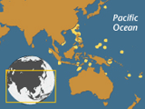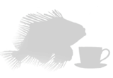
Lionfish Range
Lionfish have lot of venomous stings.

