The Sun
by williamn niu
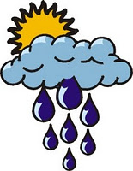

The sun is a giant gas ball hang from the sky. It is so luminous that it lighted up half of the earth. The sun is hot when you are near the equator. But it will be colder and colder as you travel away from the equator.

Sometimes, you can’t see the sun full. That because a watery cloud is covering that half of the sun. Sometimes that warns you that a rain or a storm will come.


Sometimes, you can’t see the sun at all. That’s because one of the cloud is covering the sun fully. It might be a rainy day or a windy day. But it may also be a cloudy day.

